**SSF III PROJECT LAUNCH & PLANNING WORKSHOP REPORT**

|  |  |
| --- | --- |
| **Project Title:** Joint Puntland and GalmudugPeace InitiativesProject | **Project Donor:** Somalia Stability Fund (SSF) |
| **Project Area:**4 Districts affected by conflicts in Galmudug and Puntland States in Somalia | **Consortium Members:**   1. CARE International Somalia – Consortium Lead 2. PSA - Implementing Partner – Puntland State 3. CPD - Implementing Partner – Galmudug State |
| **Event Date:** 17th November, 2024 | **Venue:** Five Star Hotel, Galkayo |

Figure 1: Group photo of SSF III Launch and Planning meeting at Five Star Hotel, Galkayo.

**Executive Summary**

On November 17, 2024, the Joint Puntland and Galmudug Peace Initiative was officially launched in Galkayo. This event marked a significant step toward promoting reconciliation and collaboration between the two states. It brought together a diverse group of stakeholders, including government officials and civil society representatives, all united in their commitment to advancing peace and fostering social cohesion.

The launch event featured impactful speeches from notable figures, including representatives from the Puntland and Galmudug regions, the Mudug regional administration, Galkayo district authorities, and various civil society committees, such as the women's committee, elders' committee, and youth committee. A key highlight of the program was the unveiling of the Joint Peace Initiatives Framework, which outlined strategic approaches for addressing regional tensions and promoting unity. Interactive sessions further enriched the event by providing attendees with an inclusive platform to share perspectives, propose actionable solutions, and strengthen collective support for the initiative. The active participation of women, youth, and traditional leaders underscored the project's inclusive nature and emphasized its grassroots-driven approach.

The overwhelming support expressed by attendees highlighted a shared desire for peace and unity. Stakeholders demonstrated their readiness to collaborate, with many pledging their commitment to ensuring the initiative's success. This event was not only a launch meeting but also a planning session aimed at accelerating the project. Following the launch, consortium partners and SSF representatives held discussions with government officials, along with a separate meeting for partners to kick-start the project.

This report documents the project launch and planning workshop conducted by a consortium of members, including CARE Somalia, the Centre for Peace and Democracy (CPD), and the Puntland Youth and Social Development Association (PSA). The report focuses on a collaborative peacebuilding initiative between the states of Galmudug and Puntland.

**Project Background**

The SSF III project target area is the border between Puntland and Galmudug states which has witnessed a long-standing inter-communal and inter-state conflict in Somalia but is now seeing an unprecedented level of ceasefire and cross-border cooperation for several years.

The city of Galkayo and its surrounding region (popularly known as Mudug) are the epicenter of these conflicts and have historically experienced frequent violent conflicts and clashes that were sporadic in nature. These clashes between pastoralist communities over resources, such as pasture, water, etc. These conflicts proliferate from rural clashes and specific disputes to wider inter-communal hostilities. Additionally, the region has been defined by underlying historical animosity between Hawiye, traditionally dominant in the south, and Darood clans, traditionally dominant in the north: a dynamic that continues to exert a strong influence in the region today.The existing traditional dispute resolution structures are often confined to de-escalating the violence at hand and are not geared to addressing their underlying drivers and root causes.

SSF III aims to support inclusive political agreements, address grievances, promote democratic processes, strengthen local governance, and enhance accountability between citizens and the state. Given the fact that the community based institutions and platforms established through the previous phases of SSF have greatly contributed to the ceasefire process, SSF III seeks to build on this history to engage partners in wider peacebuilding activities in the two states, to address:

1. Recurrent inter-communal conflicts that weaken existing and emerging political settlements, with sometimes inefficient dispute settlement mechanisms and enforcement in need of updating and consolidating, building on best practices from conflict management and enforcement in and around Galkayo.
2. Vulnerable peace processes in both Puntland and Galmudug that face risks from disputes over new and more participatory modalities of power transitions, internal political divisions, and external political pressures, to strengthen local anchors of dialogue and mediation in communities.
3. Resource competition as the climate crisis threatens to intensify conflicts over water, arable land, and pasture. Inadequate early warning systems and dispute settlement mechanisms do not yet address these challenges sustainably, particularly along the Puntland-Galmudug border.
4. Proliferation of media access, especially social media, without corresponding media literacy, which in different contexts has been shown to escalate tensions to the point of armed violence. Any efforts to promote peace must address digital platforms that amplify or even generate narratives of inter-group distrust and hostility.

**Contextual Analysis**

Contextually, Somalia is a country with a rich cultural heritage and significant challenges shaped by its geography, history, and socio-political dynamics. It has rich marine resources and pastoral lands but faces significant environmental challenges, including droughts, desertification, and deforestation. The country is vulnerable to climate change, affecting food security and water availability, leading to humanitarian crises. Despite the difficulties, there are ongoing efforts toward recovery and development.

The Federal has a close relationship with Galmudug’s administration while its relationship with Puntland is comparatively rocky. Galmudug and Puntland states are two (2) semi-autonomous regions in central and northeastern parts of Somalia respectively. The states are characterized by a rich blend of geographical, political, social, environmental, and economic aspects. Galmudug is located in central Somalia, bordered by the Indian Ocean to the east, Puntland to the north, and Southwest State to the southwest. Likewise Puntland is bordered by Somaliland to its west, the indian ocean in the southeast, Galmudug in the south and Ethipia in the southwest..

The two (2) states share their long border at the mudug region which is faced with a complex interplay of geographic, political, social, environmental, and economic factors.. The states consists of a mix of plateaus, valleys, and plains. The landscape includes both arid and semi-arid areas and experiences a predominantly dry climate, with two main rainy seasons: the Gu (April to June) and the Deyr (October to December).

Water and pasture scarcity can be a significant issue, impacting agriculture and livestock and resulting in inter-communal animosities and hostilities, displacements, and loss of lives and livelihoods.For the past five (5) months, the Mudug and Galgaduud regions have been facing repetitive episodes of active inter-clan violence. In West Mudug (Saxaqurun and Galdogob villages) heavy clan conflicts existbetween two clans, Sa’ad and Lelakase sub-clans. In the Northeastern part of the Mudug region (in Towfiiq and Afbarwaaqo Villages.),there is a conflict between Shiiqaal and Dir sub-clans. In the west of Galgaduud Region and fighting between the Dir and Mareexan sub-clans in Abudwak and Heraale Districts. There is also an active conflict between the Sacad and Wigirdac clans (Galgalad and Kaxandale villages). The Saleban and Wigirdac clans are also in conflict along the Balesenyoni and Dabad villages.

SSF project is leveraging on the prevailing circumstances in terms of the positive goodwill shown by both states.In a bid to enable the communities living in both Galkayo north and south to coexist peacefully and harmoniously, the SSF III project seeks to address these active and dormant conflicts by facilitating theestablishment/sstrengthening of the existing and new local peace structures to conduct conciliation and outreach activities. Peace messaging and peace promotion activities will accompany the conciliation activities. The project will give particular attention will be given to conflict management, conflict early warning, and climate adaptation to address climate-driven conflicts. Moreover, the project will implement dividend projects through community prioritization meetings to deepen social trust and ensure the sustainability of inter-communal peace agreements.

**Stakeholder mobilization and engagement**

Care International, CPD, and PSA began the project by implementing the project activities by first embarking on stakeholder mobilization and engagement. The consortium members were collectively and individually involved in the mobilization and engagement of key stakeholders like the Ministry of Interior and Reconciliation leadership, regional states and district administrations, religious leaders, women groups, and youth groups.

On 15th November 2024, PSAheld an engaging and productive meeting with the Governor of the Mudug Regional Administration to discuss the objectives and framework of the project. During the meeting, PSA outlined the project’s primary focus on fostering peace and reconciliation within the Mudug region. The Governor welcomed the initiative and expressed his strong support for its objectives, noting its alignment with the region’s aspirations for unity and stability. He committed to organizing committees from Puntland’s civil society to actively participate in the event and the project’s implementation.

On 16th November 2024, a team from CPD paid a courtesy call to the office of Galkayo South Municipality and representatives of the regional government to brief them on the SSF III project goal, scope, objectives, and proposed activities. The mayor and his team welcomed the project and were invited to the SSF III launching and planning workshop.

**Event Details**

As scheduled, the SSF III launch and planning workshop was held on the 17th of November 2024 at the Five Star Hotel in GalkayoSouth district. A total of 50 participants (disaggregated as Male 45, Female 5) attended the launch event. The event participants were drawn from the Ministry of Interior, representatives from the regional state, local authorities, community elders, religious leaders, women groups, youth groups, and members of peace committees. Also present were representatives from the donor and consortium members (SSF, Care International, CPD, and PSA).

|  |  |  |
| --- | --- | --- |
| ***Agenda*** | | |
| ***Time*** | ***Schedule*** | ***Responsible*** |
| 8:30 AM - 8:45 AM | Registration & Introduction | All |
| 8:45 AM - 8.55: AM | Brief word of prayer highlighting the significance of peacebuilding/reconciliation | Religious leader |
| 8:55 AM - 9:00 AM | The formal opening of the workshop | Minister (PL/GM) |
| 9:00 AM - 9:20 AM | Overview of the SSFIII project | SSF officials |
| 9:20 AM - 9:40 AM | Overview of the project objectives, proposed activities, Consortium Structure | CARE PM/consortium |
| **9:40 AM - 10:00 AM** | ***Health Caffe Break*** | **All** |
| 10:00 AM - 10:30 AM | Presentation: peace efforts and current conflict status, | Care/Consortium |
| 10:30 AM - 11:30 AM | Plenary discussion to solicit inputs from participants | Joint peace committees/FMSs officials/participants |
| 11:30 AM –12:30 AM | Remarks from Puntland and Galmudug officials and project launching. | Pl and GM Officials |
| 12:30 AM - 12:40 AM | Closing Remarks | Minister (PL/GM) |
| **12:40 AM** | ***Prayer, Lunch and Closing the Meeting*** | **All** |

After a normal climate setting, the event kicked off with a word of prayer and an Islamic lecture by Sheikh Mahammad Cali giving an Islamic perspective on the significance of peacebuilding/reconciliation. Thereafter the workshop was officially opened by the Assistant Minister Ministry of Interior, Galmudug State who welcomed the project and declared the workshop open for deliberations. Representatives of SSF and CARE International gave an overview of the project highlighting the thematic areas of focus and citing the need for close working relations with the government and other stakeholders. The consortium partners made a PowerPointpresentation of the peace efforts and current conflict status and also highlighted the outputs, objectives, and proposed activities giving the meeting participants to interact, understand, and interrogate it.

Thereafter, the governor of the Mudugregional government addressed the participants saying the program is very much needed. In his address, the Galkayo south mayor informed the participants that he is pleased with the current security situation,especiallyregardingViolent Extremism and how their administration has jointly worked together to eradicate the sameand also highlighting the emerging issue of carjackings in the Mudug region and how their two administrations are jointly addressing it to deter fuelling of inter-clan clashes. He requested that some of the proposed activities be substituted for hardware activities like the construction of roads and installation of street lighting in Galkayo town.

As part of the effort to create project ownership right from the start, the team implored the participants to give the project a name – and in that regard, several somal names for the project were flouted among them *(Daaweye*closely translated as healing, *Mideeye* – Uniting, *Kulmiye* – bringing together). The participants adopted the name *Kulmiye* – bringing together.

The workshop then graduated intothe plenary discussion to solicit input from participants. During the plenary discussions, the speakers made their contributions with some emphasizing the significance and relevance of the project adding that partners cannot bring peace and peaceful coexistence can only come from them as Mudug residents. They asserted that the project is a uniting initiative that they must take full advantage of. They also noted that the emergence of settlements has affected grazing lands and is contributing to the occurrence of resource-based conflicts. The youth representatives emphasized the need for the implementation of such projects in rural areas. He added that because the Mudug youth are part of the problem they should also be part of the solutions.

The representatives of the women groups reiterated the need for cooperation as stakeholders saying that Mugug residents made some concerted efforts during the last rainy season by holding peaceful coexistence awareness creation to the pastoral communities. She further added that through the previous SSF projects, CPD and PSA have previously supported the Mudug groups in carrying out peace initiatives in hard-to-reach pastoral areas. Adding that they look forward to similar support from this project.

During his closing remarks, the Puntland state minister for Interior thanked SSF and the team for the project adding that he is expecting the delivery of the project as the presentation and hoped that lasting peace will prevail in the Mudug region.

The project team had over lunch deliberations with the representatives of the various government levels on the project implementation and this was meant to allow the participants to interact freely. From the deliberations, the team made the following requests;

1. Closer working relations between all the stakeholders.
2. The administrations be provided with support to attend to active conflicts between communities.
3. Software activities in the projects be changed in development like street lighting and road construction.
4. Refurbishment of the Galkayo south regional offices.

**Annexes**

1. **Participants List**



1. **Pictures**

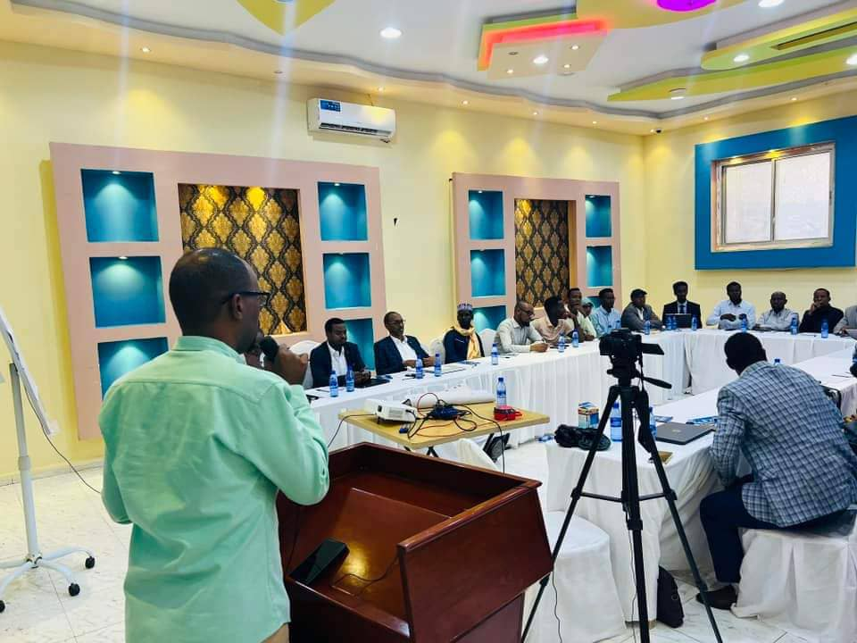

Figure 2: Mr. Abshir of SSF addressing the particpants

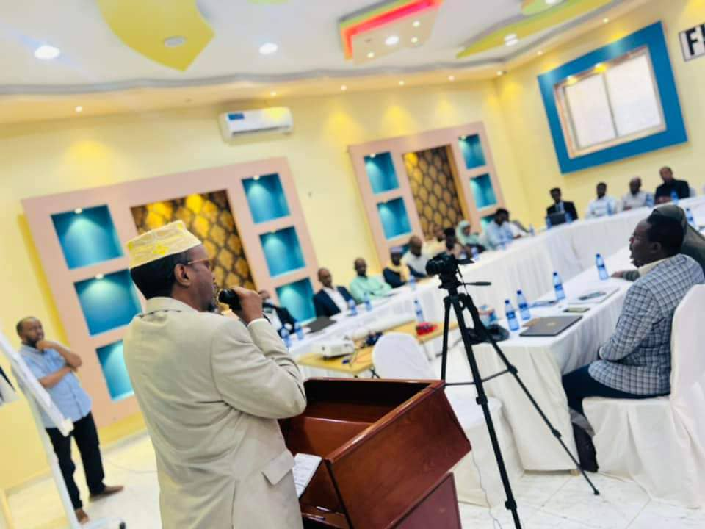

Figure 3: Puntland reginal governor gving his speech

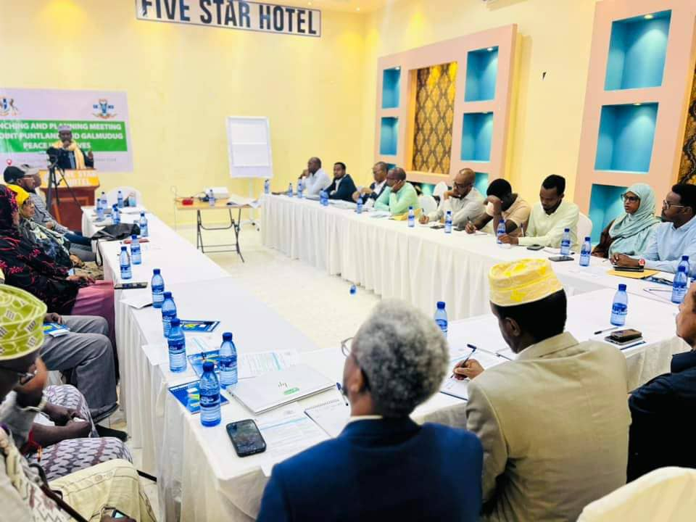

Figure 4: Acommunity elder sharing his experience on peacebuilding in the region

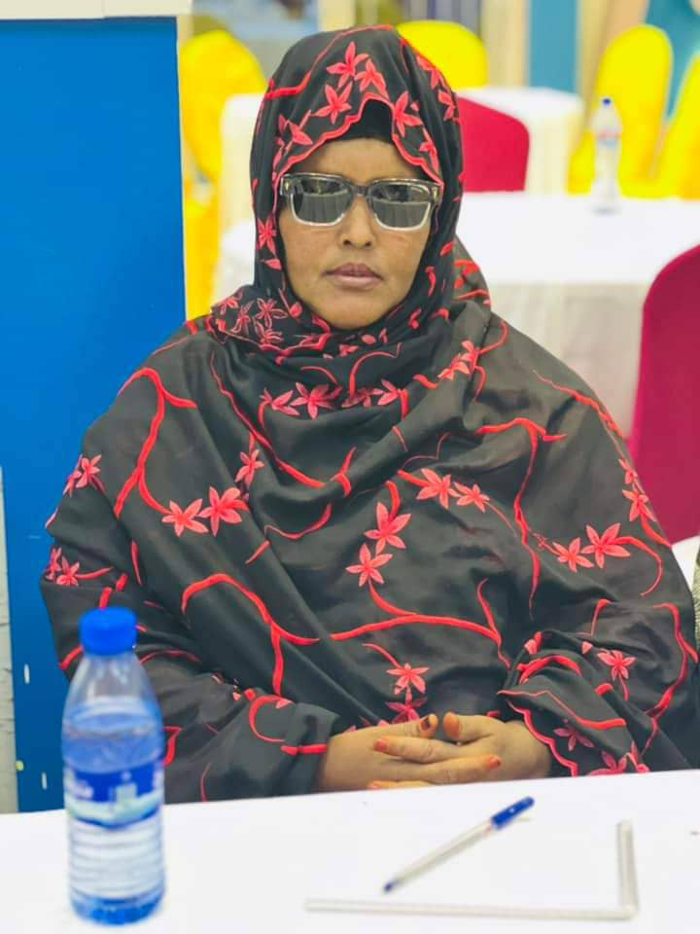

Figure 5: Madam meymuna keenly following the deliberations